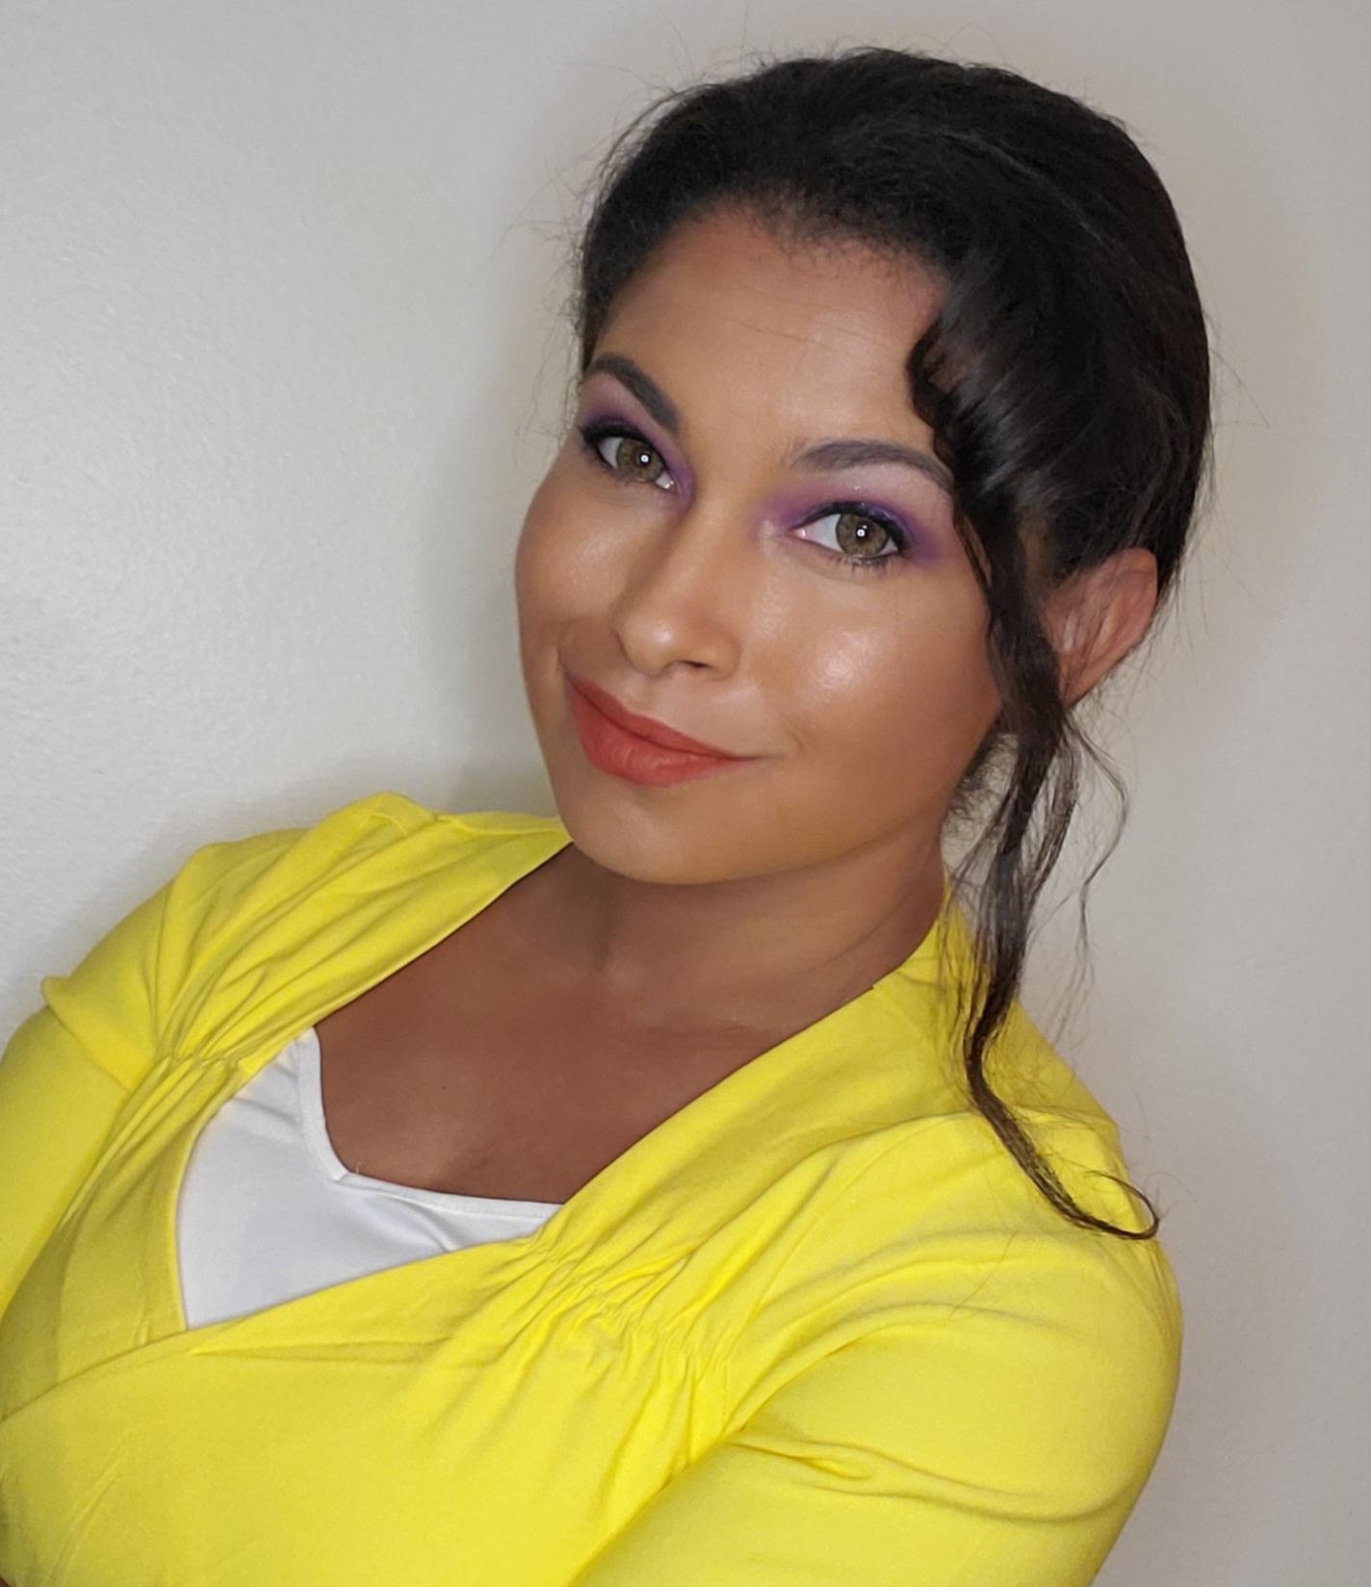
Jeanne Goodridge
Personal Information Florida, USA
Tel.: 407-718-1860 / Email: nikki.goodridge@gmail.com
Skype: ngoody315

Nationality: American
Marital Status: Single
Birth Date: 03/15/1989
Health: Well

Education and Training Florida Temporary Teaching Certificate
State of Florida, USA
July 2012 – June 2017

Florida Professional Teaching Certificate
States of Florida, USA
July 2019 – June 2024

TESOL/TESL/TEFL Certification (100 Hours)
Oxford Seminars, Orlando, USA
May 2013

Bachelor of Arts
Major: History
Minor: French
Florida State University, Tallahassee, USA
August 2009 - August 2011

Associate in Arts
Seminole State College, Lake Mary, USA
August 2008 - May 2009

Work Experience
Online High School Teacher – Advanced Placement Psychology
Seminole County Public Schools, Lake Mary, USA
August 2020 - June 2021
- Conducted online lessons monthly via Zoom
- Contacted parents and students monthly to update on progress
- Conducted verbal assessments via telephone/Zoom

High School Teacher – Advanced Placement Human Geography
Seminole County Public Schools, Winter Springs, FL, USA
August 2019 – June 2020
- Oversaw various classroom settings and students
- Maintained classroom discipline in classes of 25-30 students aged 16-18
- Member of Curriculum development team
- Co-creator of District wide content based exam

Secondary History Teacher/Head of History
Fuzhou Lakeside International School, Fuzhou, Fujian, China
August 2017 – July 2019
- Taught classes of 6-15 students aged 11-17
- Guided students through basic reading, writing, and comprehension skills
- Offered guidance to new teachers
- Collaborated with other departments on cross-subject projects

Senior Teacher – English
York English, Fuzhou, Fujian, China
October 2015 – July 2017
- Taught ages 4-16
- Oversaw logical/administrative duties
- Helped development of new teachers

High School Teacher – American History
Seminole County Public Schools, Lake Mary, USA
August 2014 - June 2015
- Oversaw various classroom settings and students
- Maintained classroom discipline in classes of 25-30 students aged 16-18
- Member of Curriculum development team
- Co-creator of District wide content based exam

Kindergarten Teacher
Wuhan, Hubei Province, China
October 2013 – June 2014
- Oversaw various classroom settings and students
- Maintained classroom discipline in classes of 25-30 students aged 4-5
- Guided students in learning English as a second language

High School Teacher – American History
Seminole County Public Schools, Lake Mary, USA
October 2012 - May 2013
- Taught classes of 25-30 students aged 16-17
- Encouraged student engagement in the subject matter
- Guided students through basic reading, writing, and comprehension skills

Volunteer Experience
Committee Developer
Houses Committee, FLIS, Fuzhou, Fujian, China
November 2018 – July 2019
- Developed a committee that created, organized and administered houses to our secondary school
- In charge of deadlines, due dates and making sure materials were completed in time

Head of Edmentum Development
Edmentum Department, FLIS, Fuzhou, Fujian, China
October 2018 – July 2019
- Delivered trainings on Courseware and Edmentum program that allowed for blended learning in the classroom with online courses and resources
- Collected data to help push blended learning to future accreditation organizations

Additional Skills and Experience
Languages: French (Beginner), Mandarin (Beginner)
Skills: Collaboration skills, creative input, supportive, motivates others, confident public speaker, task/goal oriented, Microsoft office skills, CSS, Javascript, HTML5, SQL

References Available upon request

